2019-2020

Welcome to
Kindergarten
Timeline | page | 1
Translators, contacts | page | 1
Entrance Age | page | 2
A day in kindergarten | page | 2
Teaching philosophy | page | 4
Curriculum | page | 5
Transportation | page | 8
Cafeteria | page | 10
Clinic services | page | 11
Helping your child | page | 12
Parent resources | page | 15
Kindergarten readiness | page | 16
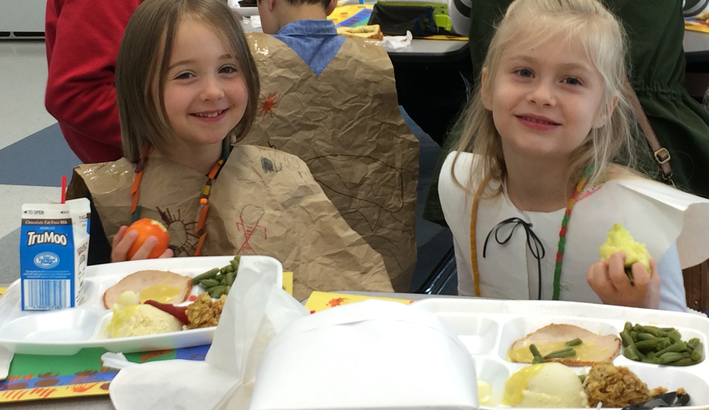
at
North Springfield!

Share the excitement of your child’s primary school years! Find out about our kindergarten program and learn how you can enroll your child. Countdown to August 28th!

K-5 School Hours!

Monday - Friday

8:35 a.m. - 3:30 p.m.
North Springfield Elementary •7602 Heming Ct, Springfield, VA 22151 • (703)658-5500 •FAX (703)658-5597• www.fcps.edu/NorthSpringfieldES
Early - August | Physicals and health documentation must be submitted to the school so that a child may be assigned to a class. A child is not assigned until all enrollment requirements are complete.
Mid - August | Welcome letters with class assignments including the name of the teacher and room number will be mailed to parents approximately one week before school starts.
August 22 | Save The Date: School wide Welcome to school Open House
August 26. 2019 | School starts!
Timeline

Spanish 571-423-4950, Korean 571-423-4951, Vietnamese 571-423-4956
Make your connection with these Parent Information Lines. Get general information about FCPS and answers to your questions. Call anytime and leave a message. You will receive a return phone call in Spanish, Korean, or Vietnamese within 24 hours.
Translators, contacts

North Springfield School Contacts at 703-658-5500
Chad McRae, Principal Donna Kruse (SIA), School Registrar
Leslie Malkowski, Assistant Principal Jackie Geist, Administrative Assistant

Entrance age
A child may enter kindergarten if he/she has reached age 5 on or before September 30 of the year he or she enters.

Required enrollment
Virginia law, Section 22.1-254, requires that children who will reach their fifth birthday on or before September 30 must be enrolled in school unless the parent or guardian notifies the principal in writing that they do not wish the child to attend school until the following year. A child who will be six on or before September 30 must attend school.
A day in kindergarten
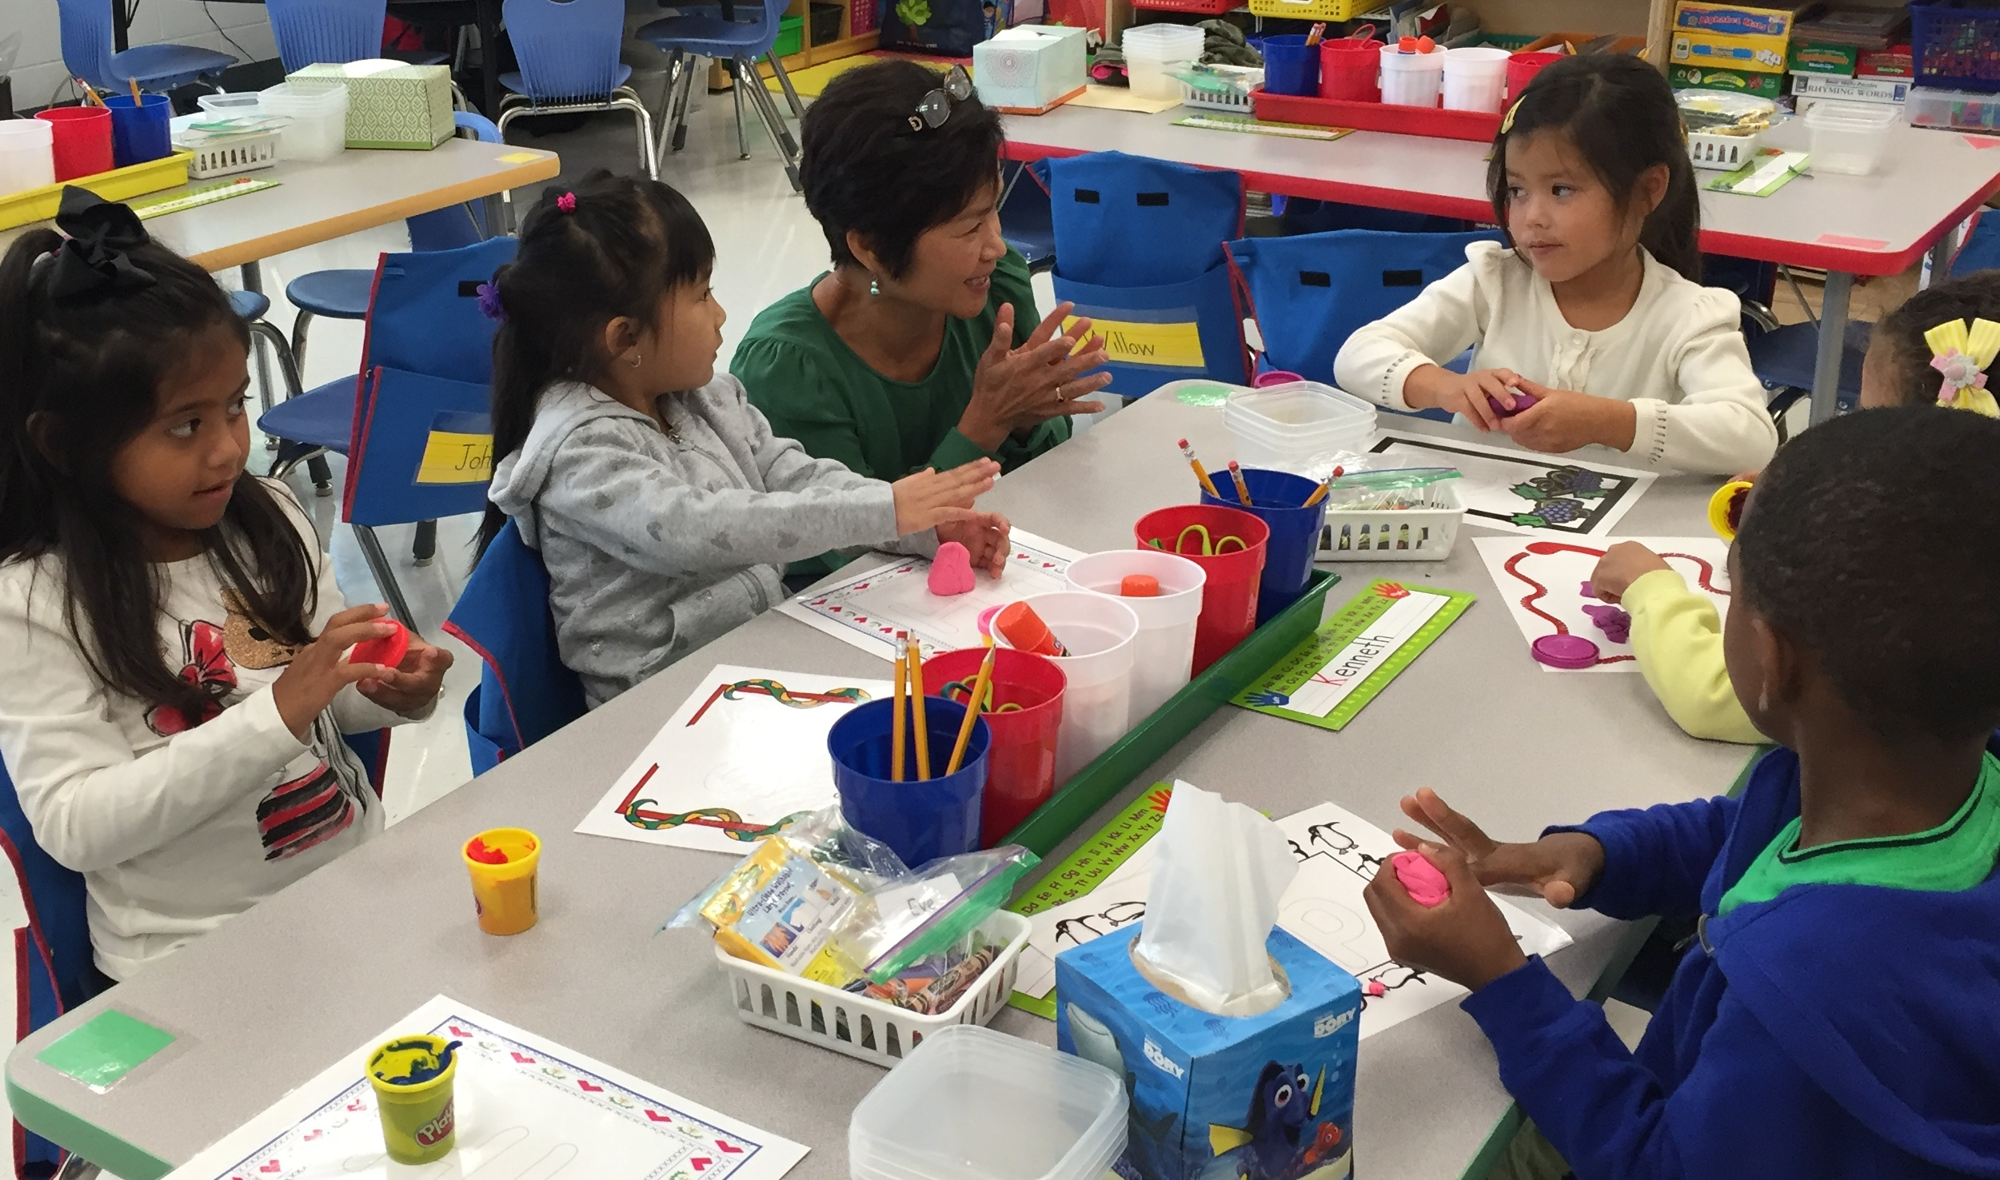
We are fortunate to offer a full-day kindergarten program. Full-day
kindergarten allows children time to explore topics in-depth and in a less
rushed atmosphere. The ratio of transition time (arrival and opening, clean
up and departure) to class time is reduced so there is more instructional
time. Students are able to participate in activities offered to other primary
children, such as music and PE classes with specialists, and lunch.

What is a typical day in kindergarten like?
A kindergarten day must include a balance of large group, small group and center activities, as well as many opportunities for movement, active play, and hands-on investigations. The following sample is one way for organizing a full kindergarten day. The actual plan will vary according to teaching styles, classroom needs, and special programs. Any schedule must be flexible enough to allow for the “teachable moment,” unplanned events, and time of year. For example, total group lessons that require attention in a large group may be shorter in September.

8:35 | - | 8:50 | Arrival and school TV broadcast/announcements followed by “Networking;” students choose “table activities” such as Legos, puzzles, library books, paints
8:50 | - | 9:20 | Circle Time (total group); attendance, calendar, weather, greetings, morning message, music and movement, plan for the day
9:20 | - | 10:20 | Language Arts (total group); shared reading and introduction of reading/writing skills
10:20 | - | 11:00 | Individual and small group work, and centers; children are working at centers independently or in small groups with an adult based on their individual needs  Daily 5  Writer’s Workshop
11:00 | - | 11:20 | Recess
11:20 | - | 11:30 | Snack, story, Show ‘n Tell
11:30 | - | 11:45 | Math Opening (total group); math read aloud, music/movement related to numbers and counting, introduction of new concepts
11:45 | - | 12:30 | Individual and small group work, and centers, related to math
12:30 | - | 1:00 | Lunch
1:00 | - | 1:20 | Quiet rest time
1:20 | - | 2:20 | Science/Social Studies
2:30 | - | 3:20 | Special subjects such as art, computers, music, PE, guidance, library, and special projects; kindergartners have 60 minutes of art with the art specialist each week, two 30-minute music classes with a music specialist, and three 30-minute classes with the PE specialist. Kindergartners visit the library for 30 minutes each week and participate in lessons with the guidance counselor. Classes also visit the computer lab on a regular basis.
3:20 | - | 3:30 | Dismissal
My child still takes a nap. Will there be nap time?
The full day kindergarten schedule includes a “quiet rest time”. Not all children need a nap, but all children benefit from periods of relaxation to balance their active play. Teachers anticipate that the need for quiet time may be greater in the beginning of the school year as the children become acclimated to school. The transition back to school is hard for children…and teachers!

What does the research say about full-day kindergarten?
Research studies confirm that attendance in full-day kindergarten results in academic and social benefits. After comparing half-day and full-day kindergarten programs in a statewide longitudinal study, researchers found that full-day kindergartners exhibited more independent learning, classroom involvement, and productivity in work with peers. (Cryan et al.,1992; Karweit, 1992). In a later study, full-day kindergartners outperformed half-day students on every criterion measured by norm-referenced achievement tests. Attendance was found to be significantly higher, and fatigue, sometimes assumed to be a problem for children attending full-day, was not a significant factor. Fewer than 8% of all students were identified by parents, teachers, or independent observers as experiencing significant loss of engagement in school (Hough and Bryde, 1996).

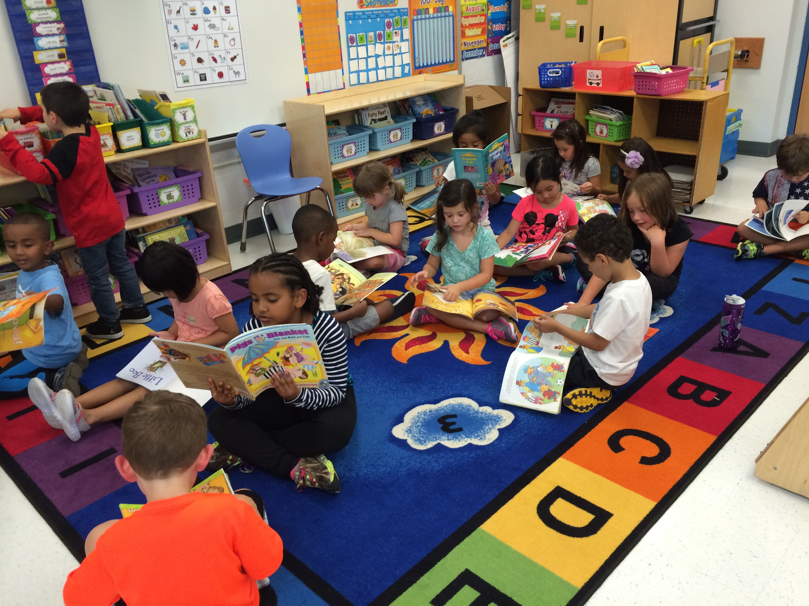
Our teaching philosophy
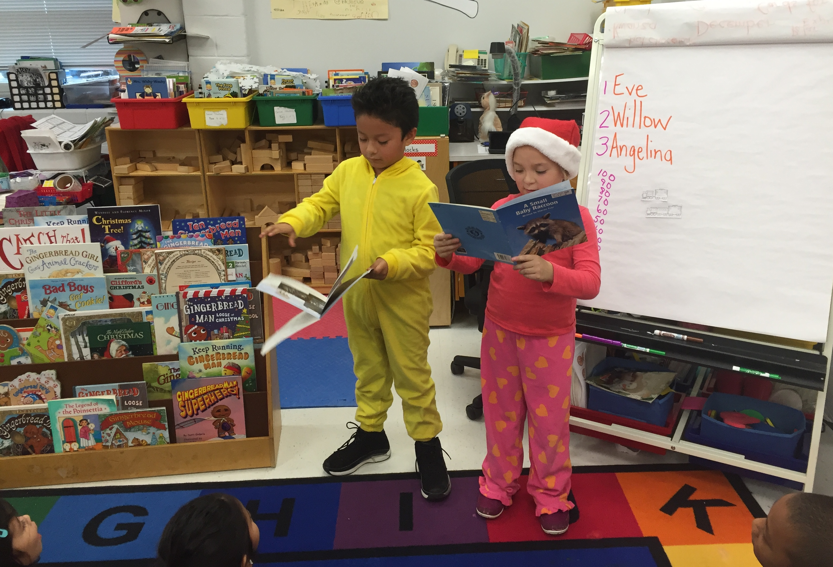
We believe that the kindergarten program should be adaptable to each child’s needs, interests, and level of development. A variety of activities tailored to individual needs help children grow socially, emotionally, physically, and intellectually.

Our kindergarten program:
- Focuses on oral language development as the basis for writing, reading, and thinking.
- Builds on, improves, and increases the knowledge skills that children bring to school.
- Promotes an appreciation of the similarities and differences among people.
- Incorporates active learning through body movement activities, manipulation of learning materials, and interaction with others.
- Uses ongoing performance assessment to observe, document, and analyze children’s learning behavior in the areas of language arts, math/science, and fine and gross motor skills.
- Encourages a love of learning.
Children learn, grow, and develop at different rates. The Fairfax County Public Schools’ early childhood curriculum takes into consideration these differences in young children. Through customized instruction, all students will progress at their own rates of development. We want each student to experience success and build a positive self-concept.
In the elementary years, a sound foundation in speaking, writing, reading, and mathematics prepares students for future academic success. Wherever possible, concrete objects and materials introduce concepts to students. Activities that include learning experiences using real objects help young children understand concepts and ideas prior to the introduction of abstract symbols.
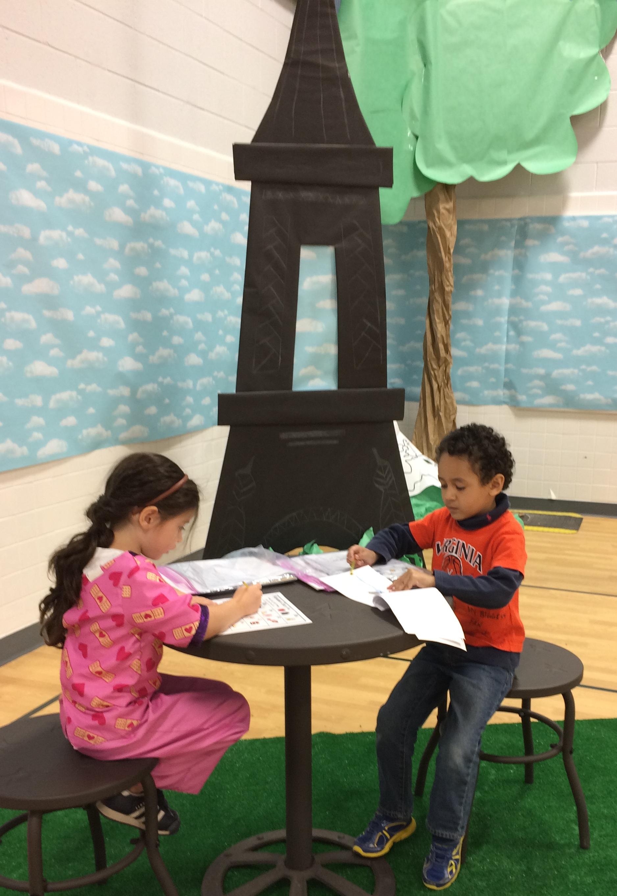
The kindergarten curriculum

Reading and writing
Children learn about reading and writing from hearing stories read aloud;
seeing others read and write; reading and writing with the teacher; and having
opportunities to interact with books, writing materials, and other forms of print.
These learning experiences occur daily. When reading and writing, the children are encouraged to draw on background experiences and pictures, use meaning, language structure, and phonics (letter-sound) cues. Big books (books with large print and pictures), class books, and stories or poems with rhyme, rhythm, or repetitive patterns are appealing to kindergarten children and are used daily in the classroom.

Development of letter-sound relationships occurs within the framework of stories the children read and write. This specific instruction is always tied to meaning. Foundations for reading and writing are built on what children already know and by expanding and enriching their language through experiences that encourage listening, thinking, and speaking.

Mathematics
In kindergarten mathematics, children begin by using concrete objects to represent numbers and compare quantities (such as many, few, none, same, and different), represent and extend patterns, match and identify shapes, and sort objects. Problem-solving skills are encouraged and developed throughout the year as children make up their own math stories, solve and illustrate simple story problems, and share their thinking about how a problem is solved.

Science
In science, children investigate and understand simple patterns in their daily lives by recognizing classroom routines, observing and discussing daily weather patterns and seasonal changes. Children begin to investigate and understand the needs and life processes of plants and animals. Activities with shapes, magnets, sand and water encourage further discovery, investigation, and problem solving.

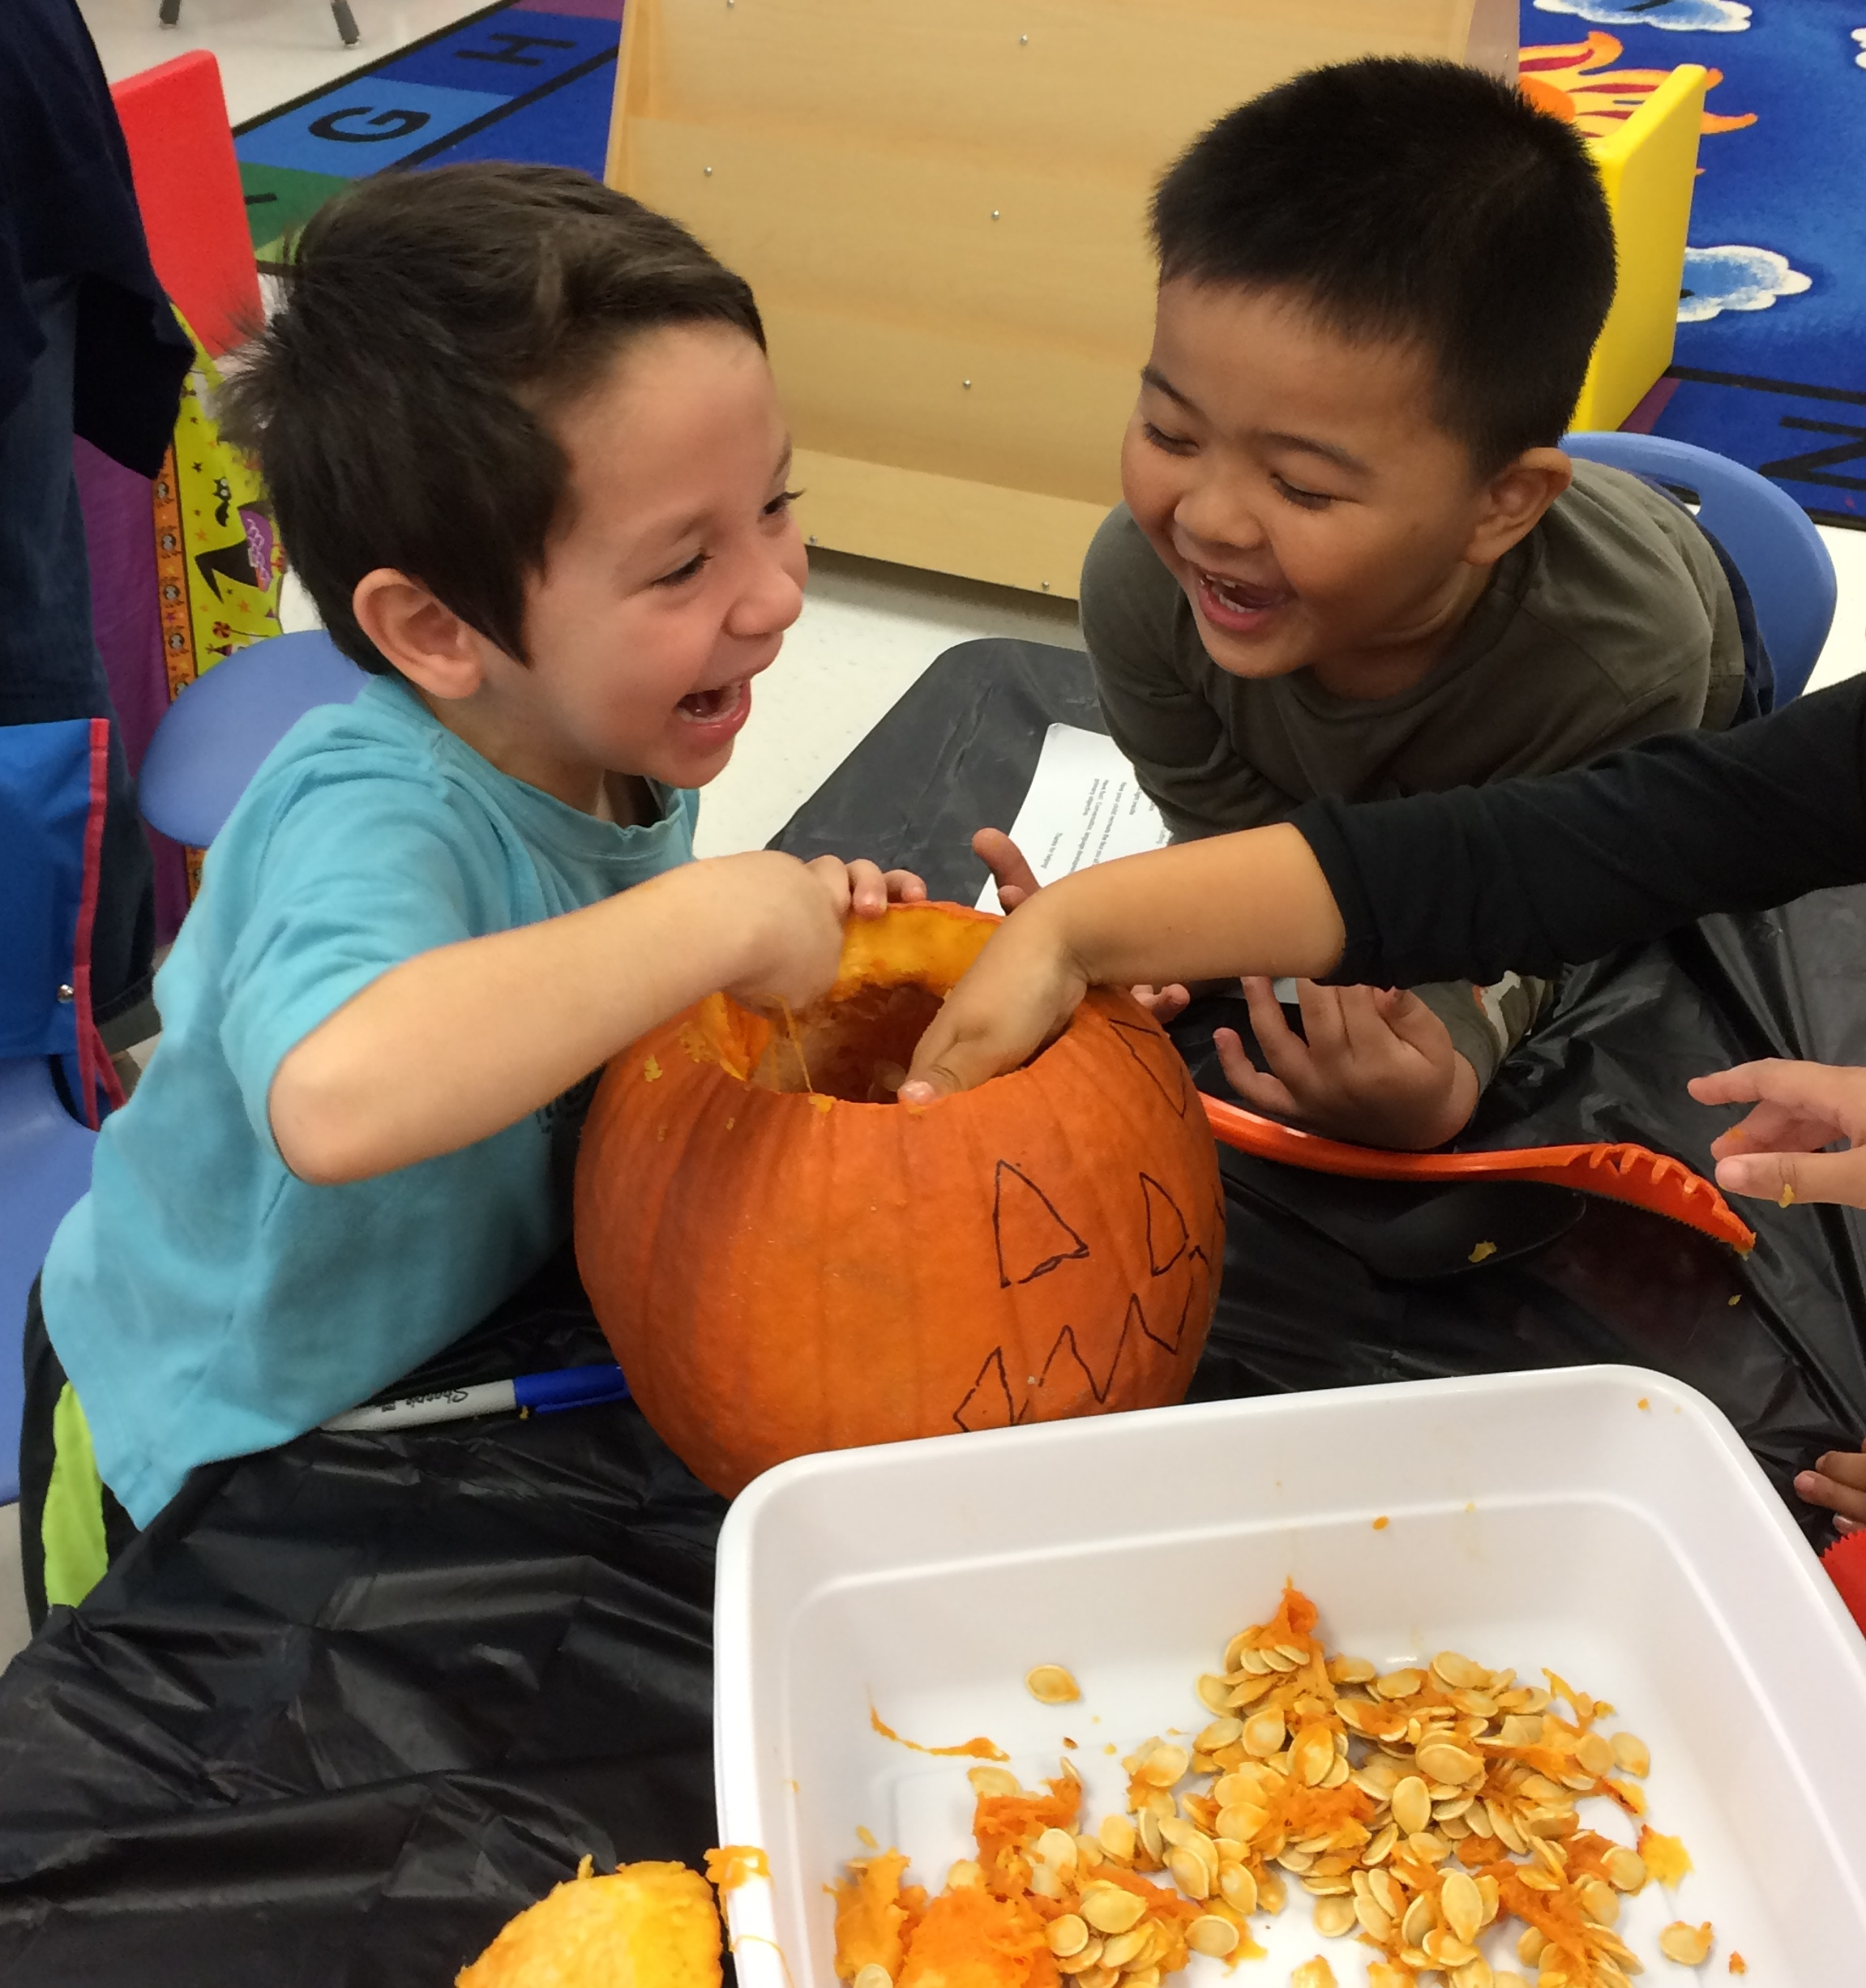
Social studies
Children examine a variety of picture books, information books, and other materials to acquire additional knowledge about themselves as individuals, part of a family, and a community. Children share family traditions and celebrations, observe changes within the community, and explore American traditions, leaders and historical events. In geography, children begin to learn basic terms and skills, and locate areas of land and water on maps and globes. Differences between economic needs and wants are included in the social studies program. Children participate in music, art, writing, technology, poetry, and dramatic representation activities as part of these learning experiences.

Art
During weekly art classes, children explore paint, drawing materials,
stitching, various types of weaving, collage, architecture, ceramics,
and sculpture. Kindergartners have the opportunity to work on problem-
solving skills in group projects like murals and sculptures. They also learn about famous artists.

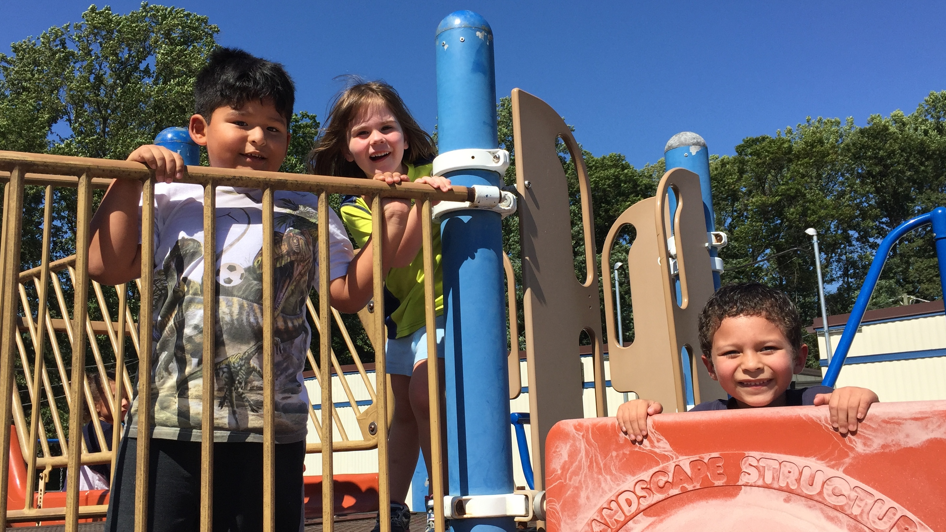
Music and movement
The music and movement strand provides students with integrated activities in music and movement. Children are involved in activities which emphasize the development of motor skills, physical fitness, coordination, musical skills, and creative expression. Children use balls, plastic hoops, and musical instruments to help develop these skills.
The kindergarten program utilizes a variety of learning centers for small group and individual learning. Center activities incorporate skills used in different areas of the kindergarten program. These centers include blocks, art, math, science, listening, dramatic play, and beginning reading and writing centers. Centers may change to meet the needs of a particular unit of study.
Physical education and health
Primary children have an insatiable appetite to be active. The PE program fosters skill development, promotes lifetime fitness habits, and provides lots of fun! By focusing on skills rather than sports, children participate in a wide variety of activities to develop space awareness, balance, throwing and catching, and other motor skills. Gymnastics, rhythm, and dance are also important elements of the PE program.

Personal health and safety lessons are also important components of the kindergarten curriculum. Topics include nutrition, personal hygiene, avoiding harmful substances, and staying away from strangers. Each fall parents receive a description of the grade-level Family Life Education (FLE) lessons with the choice of opting a child out of some or all lessons.

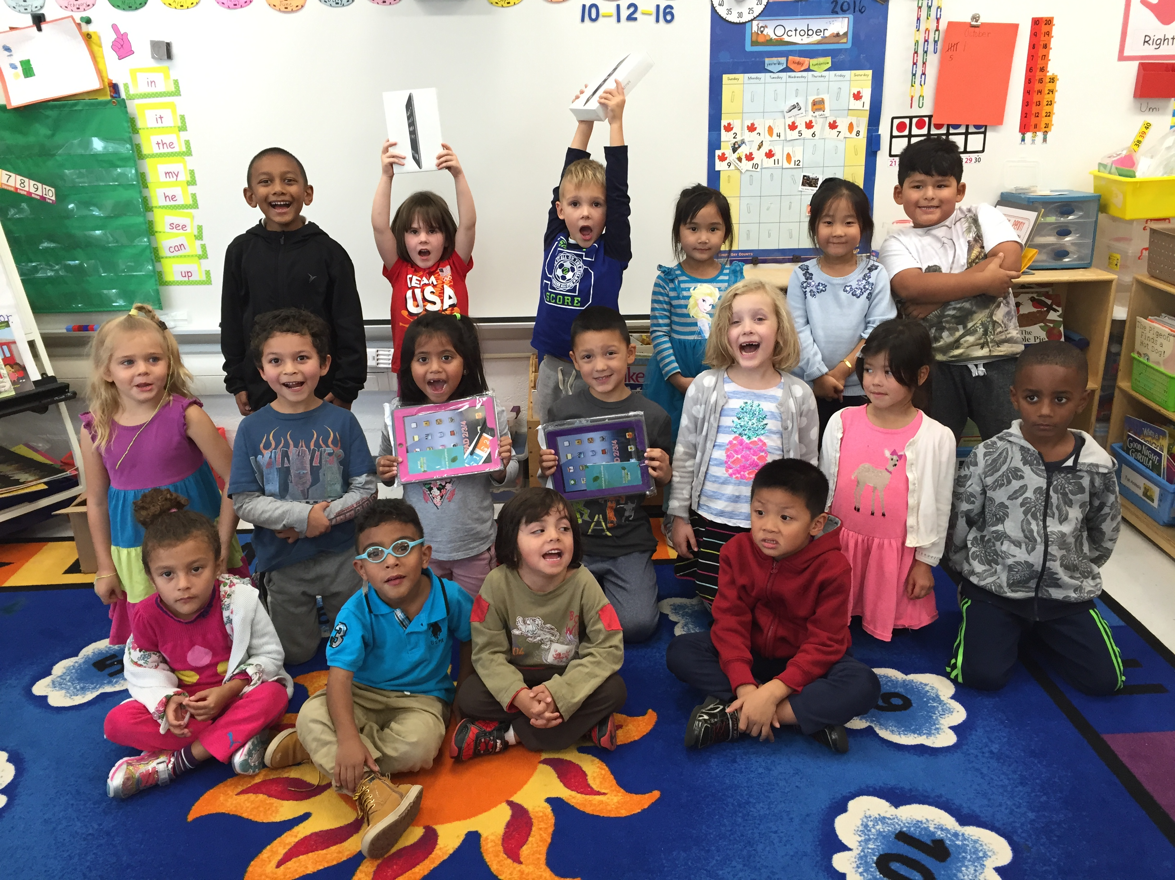
Technology
Kindergartners are involved in a variety of computer online and offline activities. These activities give students a basic introduction to the computer and keyboard. Kindergartners also use appropriate curriculum software as a tool for learning.

Advanced Academic Programs (AAP)
The Advanced Academic Program at the kindergarten level has two components. The first is a series of nine lessons, called Response Lessons, which are taught in all kindergarten classrooms. The purpose of these lessons is to encourage critical and creative thinking in all students, and to help identify the special learning needs of selected students.

The second component of the program, Differentiated Services, is an adaptation of learning activities for selected students. Students are identified for Differentiated Services based on the observed learning needs which require special accommodations in the classroom.
Transportation

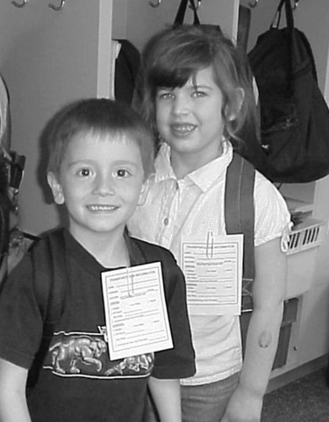
Bus riders
Bus service is provided for children who live more than one mile from school or where walking is hazardous. We require that a parent, guardian, or sibling in 7th grade or higher be present to receive the kindergartner at the bus stop.

Walkers
Kindergarten children who walk home are required to have a parent or designated adult meet them at Door #10. (This door is the exit near the cafeteria.)

Car riders
The “Kiss and Ride” lane was established to preserve students’ safety. Beginning at 8:15 am students can be dropped off in the morning at the Kiss and Ride lane (Door #2). As you enter the parking lot, the lanes divide. The “through traffic” lane was created for those who wish to park in a parking space. This is a one-way traffic flow pattern. The lane to the right has been designated as the Kiss and Ride drop-off area. Students are not permitted to exit cars before they enter into this area. Parents should pull their car as far forward as possible before stopping to unload students. Six or seven cars will be able to unload simultaneously. In order to prevent delays, your child should be ready to exit the vehicle on the curb side and goodbyes should be kept brief. Exit the Kiss and Ride lane promptly after unloading; however, do not pass other cars unloading. Please observe the solid yellow line. In the afternoon students will be released at 3:30 at Door #2.

At no time may a student unload from their vehicle at the front door (Door #1). To enter Door #1, vehicles must be parked in a designated parking space and then children must be escorted into the building by an adult.

Changes in transportation arrangements

Arrangements to visit friends should be scheduled after children arrive safely at home in the afternoon. Changes in daily transportation should be avoided whenever possible. Consistency of routine is important for young children.

Should emergency childcare require that another child ride home on the bus to your house, please contact the school office to discuss the situation. Those requests will be approved only on a space-available basis, and a back-up plan needs to be in place should there be insufficient seating. Regular riders will receive priority and if space is not available, an adult must be able to pick up the child at school.

In the event that your child must walk or ride home with a friend, we ask that your child and the friend bring a note to school confirming both parents’ approval of this arrangement. If a note is not received from both sets of parents, the child will go home the usual way.

Helping your child find his classroom in the morning
Upon learning the teacher’s name and room number, parents should record this information. Staff members are stationed outside and throughout the building each morning to help children find their classrooms.

Authorizing others to pick up your child
Be sure to list those persons who may pick up your child on the Emergency Care Form sent home on the first day of school or available online. This is especially important if your child becomes ill at school or misses the bus, or if you are delayed in traffic. Update this form throughout the year as necessary. The school cannot release your child to neighbors or relatives unless they are listed on the Emergency Care Form.

Cafeteria
Breakfast
Students may purchase breakfast for $1.75*, which includes juice, milk, and a choice of cereals, biscuits, and other breads. A menu is sent home to parents during the first week of school and monthly during the school year. To participate in the breakfast program, students should go directly to the cafeteria when they arrive at school. Breakfast is served from 8:15 – 8:35 am.

Lunch
Nutritious school lunches are served in the cafeteria daily at the current cost of $3.25*. A menu will be sent home monthly. Milk is served with each lunch or may be purchased separately for
$ .60* per half pint. A choice of skim chocolate milk and low-fat or skim unflavored milk is available. Children with milk allergies may receive juice upon receipt of a physician’s statement.

Cafeteria account
Each child will be assigned an account number. This number will follow your child as he goes from grade to grade. The number will be sent home so you can practice it with your child. Adults will help the students get through the lunch line. Parents are able to add money or check account balances by joining www.myschoolbucks.com. There is a $1.95 convenience fee to add money online. Money can also be added to the child’s account by sending cash or check (made out to NSES Food Services) in an envelope marked with the child’s name and teacher’s name.

Joining your child for lunch
Parents are invited to join their child for lunch. Adult lunches cost $4.25*. We ask that dining guests check in at the office for a visitor’s badge before meeting the child’s class in the lobby.

Subsidies
Applications for free or reduced price breakfasts and lunches are sent to all families in August. They are also available at the school throughout the year in the school office. All requests are confidential and prescribed state guidelines are applied to each request.

* Prices are subject to change.

Health Room services
Annual health screening
Vision and hearing screening of all kindergartners, third graders, and newly enrolled Fairfax County students is conducted each fall by the public health nurse, health room aide and health room volunteers. This is only a brief screening; parents should continually be alert to identify vision or hearing difficulties which indicate the need for examination by a specialist.
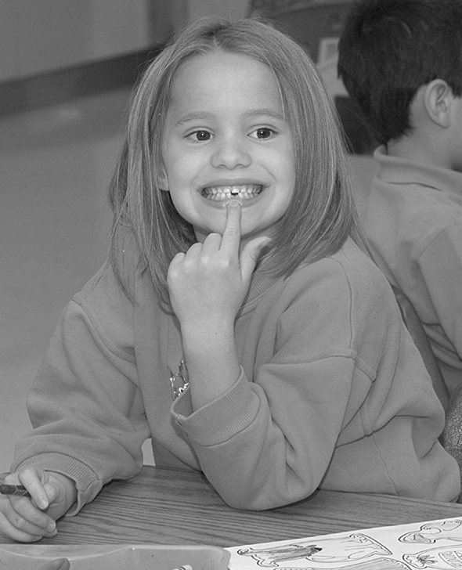
Health Room services
Health room services in the school, including the administration of medication and modified first aid, are performed by the health room aide and office staff. According to state regulations, the health room staff may provide care only for minor illnesses and injuries. If the child’s condition requires more attention, the parent will be contacted.
Medication at school
Students may take medication at school under strict adult supervision and in accordance with School Board guidelines. Forms authorizing the school to administer medication are available in the school office or at www.fcps.edu. Cough drops and throat lozenges may be carried and used by students as needed, provided that they are in the original container or packaging.

With a parent/guardian’s signature and a physician’s signature, prescription and over-the-counter medication may be stored in the health room and given as needed throughout the school year.

With a parent/guardian’s signature only, antibiotics, antiviral, and over-the-counter pain relievers may be stored in the health room and administered at school. Any other over-the-counter medications may be given for up to ten consecutive school days with the parent/guardian’s signature. Beyond ten days, a physician’s signature is required.

A parent must transport any medication to and from the school health room. Students may not transport medication in their backpacks.
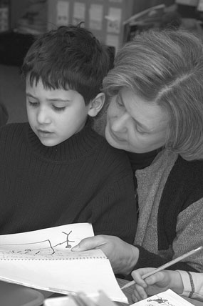
Helping your child

Support your child’s progress
Parents are a child’s first teacher and they know their child in ways no one else does. By working in partnership with us, parents can help their child reach his/her fullest potential.
A parent’s primary role is one of encouragement and reinforcement. Parents can enhance what is experienced at school and foster a sense of excitement and a love for learning. Opportunities for parents to encourage the natural development of the child are endless.
Children learn to read and write in a manner similar to the way they learned to speak. They observe others reading books, directions and signs. They watch those around them write shopping lists, and letters. Through watching others, they try these activities. By reading license plates, food labels or other objects around them children learn that print is meaningful and useful. Whether scribbling on scraps of paper, writing a note to a parent with letter-like marks, or reading a book by looking at the pictures, these attempts should be accepted and encouraged.
Your child will exhibit many beginning reading and writing behaviors throughout this year.
- Approximate Reading is retelling a story from memory using the story’s picture clues. Your child may use his/her finger to point to words or pictures.
- Scribble Writing is making different lines or strokes which may or may not refer to specific words or letters.
- Labeling pictures or commenting on items found in books.
- Reciting a Story Aloud while looking at pictures.
- Temporary Spelling is the use of a letter or letters to represent a word or phrase. For example, l or lik may be used to represent the word like.

To help, read with your child every day. Read a variety of stories (folktales, fables, information books, and poetry). Read different written materials such as cereal boxes, recipes, books, magazines, signs, and greeting cards.
- Model reading and writing in your home. Involve your child in writing shopping lists, telephone messages, or reading letters from relatives. Let your child see you reading books, instructions, newspapers, and magazines.
- Expose your child to wordless picture books. These encourage your child to use picture clues to make up his/her own stories.
- Encourage your child to take chances. Build the concept that learning means taking chances and not always being right.
- Take trips to the library.
- Include your child in family discussions. Use questions that involve who, what, where, why, and when.
- Use family activities as a chance to explore new language. Visit and talk about the zoo, library, park, store, movies, or sports events.
- Play games like “Simon Says” that involve following directions.
- Sing and read simple songs and nursery rhymes like Twinkle, Twinkle, Little Star; Wheels on the Bus. Clap the rhythm.
- Read and follow recipe directions. This provides children with the opportunity to listen to and follow step-by-step directions.
- Reread favorite stories. Allow your child to choose the book for story time.
- Provide writing materials like pencils, pens, chalk, markers, crayons, different sizes and colors of paper, envelopes, and tape. Allow your child to write messages to family members, book authors, or friends. Also leave notes on the refrigerator or in a lunchbox from you to your child.
- Ask your child questions that require more than a “yes” or “no” answer. Example: “What do you think will happen to Goldilocks?” Look at books and magazines and ask questions about what was read.
- Listen to your child when he or she speaks. Show that you are interested in what is being said. This encourages good listening habits.

Help your child develop muscle coordination by letting your child
- Draw letters or numbers in the sand or on the sidewalk with a paint brush and water.
- Use puzzles, clay, or dough.
- Use crayons, scissors, snaps, buttons, zippers.
- Run, hop on one foot and two feet.
- Catch a ball.

Help your child develop independence by letting him/her:
- Make simple choices.
- Help choose his or her clothing.
- Perform simple household tasks.
- Dress himself or herself when possible.
- Find letters of his or her name in books, magazines, or signs.
- Sort things by size, shape, and color (clothing, buttons, dishes).
- Count seeds, pennies, stamps, M&M’s or any other objects.
- Locate food items in the grocery store by looking at the pictures and the labels

When reading with your child:
- Let your child have opportunities to choose what book he/she wants to read.
- Pick a quiet time to read.
- Sit close to your child. Let your child see the pictures and print.
- Point to words as you read them. Refer to your child as a “reader.”
- Reread the book and encourage your child to join in with familiar phrases, turn the pages, and predict what will happen next.

PTA
An active PTA sponsors family socials, like Heritage Night and Bingo Night, and funds assemblies, field trips, and materials that enrich your child’s school program. Parents can and do make a difference in the education of their children by joining other families and staff as members of the North Springfield PTA. A packet of general information about the PTA is sent home on the first day of school. Everyone is encouraged to join the PTA. Ideas, suggestions, and concerns are always welcomed.

Volunteering

North Springfield Elementary School enjoys the support of an extensive volunteer program. Parents and community members are invited to participate by contacting a PTA officer, the classroom teacher, or the school office. Volunteers typically work with students, assist in the library, help with art projects, perform clerical jobs, prepare instructional materials, or work on PTA projects. Schedules and responsibilities are as varied as our volunteers and their many talents. Parents receive a North Springfield Volunteer Sign-up sheet that lists opportunities as well as the guidelines for becoming a volunteer.
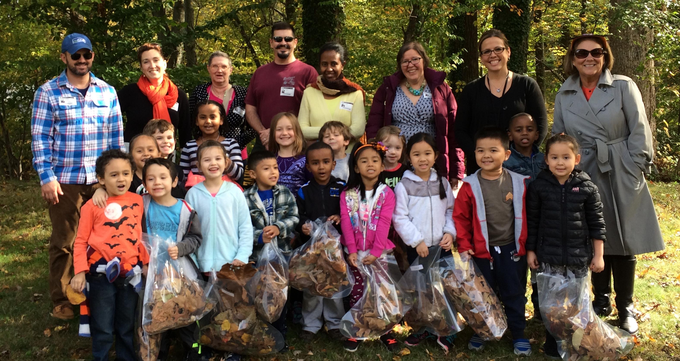

Parent resources
Day care (SACC)
School Age Child Care (SACC) is a Fairfax County Office for Children program for children attending elementary school. The program accommodates families in which all adults in the home are working, attending school, or are disabled. The program provides professional care for children attending kindergarten through sixth grade, and is offered at most elementary schools, including North Springfield. Fees are based on gross household income.

SACC operates school year, summer, winter, and spring programs. During the school year, children may enroll in separate sessions: before school – 7:00 a.m. until school begins, after school – from the end of the school day until 6:15 p.m. Summer and winter/spring holiday sessions are offered at consolidated sites from 7:00 a.m. until 6:15 p.m. Call SACC Registration at 703-449-8989 to receive information or enroll.

Fairfax County Health Department
The goal of the Fairfax County Health Department is to protect public health and the environment in which we live. Services include:
- Immunizations, such as hepatitis B, measles, mumps, rubella, tetanus, polio, diphtheria, and pertussis
- Case management for high-risk children and families
- Children’s specialty services (neurology, cystic fibrosis, eye surgery, orthopedic)
- Primary health care for low income, uninsured county residents (pediatric care)
- Dental services for children
- Vision screenings and examinations
- Referral for other services within the county
For more information, call 703-569-1031 (TDD 703-591-6435).

Parenting classes
Fairfax County’s Center for Promoting Family Learning and Involvement offers classes, parenting tips, and resource for families. Their schedule includes single and multi-session classes for parents, family members, and caregivers of infants through teens. Classes are taught by professionals and are scheduled seasonally, three times per year. Most classes are 2 to 4 hours long and meet during the day, evening and/or some weekends.

Kindergarten readiness is…
Children entering kindergarten demonstrate a variety of learning behaviors. Indicators of kindergarten success include the following:

Oral language, reading, writing

•Says his/her first name | •Identifies colors
•Follows simple directions | •Identifies some letters of the alphabet
•Answers simple questions | •Writes his/her own first name
•Recites some nursery rhymes | •Discusses a favorite story
•Retells a familiar event or story | •Pretends to “read” a book
•Participates in word play (kuplink, kuplank, kuplunk) | •Attempts writing by using scribbling, print-like symbols, or strings of letters
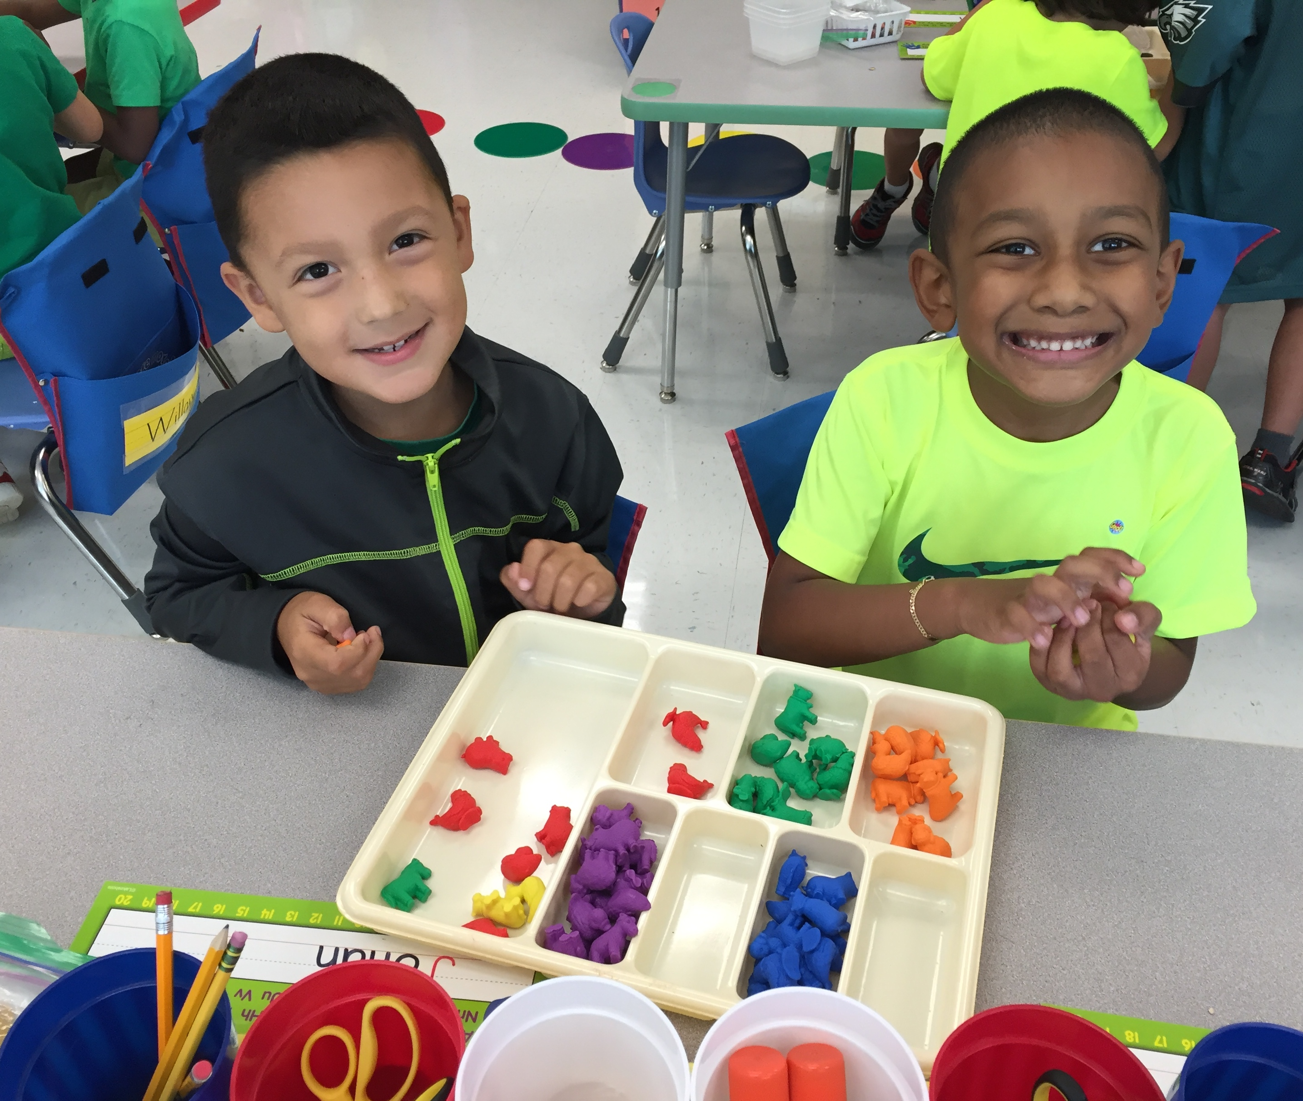
Mathematics
•Identifies some shapes
•Matches objects like socks, shoes
•Notices similarities, differences
•Sorts and classifies objects
•Tries to count to 10
•Touches or points at objects when counting
•Arranges objects from shortest to tallest
•Uses math language like bigger, smaller, tallest, shortest

Social-emotional, physical

•Makes choices, takes turns | •Tries new things, finishes new tasks
•Uses self-help skills (dressing, toileting, eating) | •Hops, jumps, gallops, runs, leaps, climbs, balances
•Shares with others | •Throws and catches a ball
•Helps with chores at home | •Buttons and zips
•Begins to demonstrate independence and show self-confidence | •Alternates feet when walking up steps  •Expresses thoughts, feelings

Notes
We look forward to working with you and your child at North Springfield. We want this kindergarten year to be a most successful one!



